**Software Engineering II Project**

**Digital Cookbook**

Part task: Search in region

**Group C**

Hengyu Wang

Jierui Li

**Content**

**1.** **Specification** 3

**1.1.** **Description** 3

**1.1.1.** **Digital cookbook** 3

**1.1.2.** **Additional task** 3

**1.2.** **User characteristics** 3

**1.3.** **Data** 3

**1.4.** **Functional requirements** 3

**1.5.** **Non-functional requirements** 3

**2.** **Architecture** 4

**2.1.** **Use case diagrams** 4

**2.2.** **Structure/MVC** 4

**2.3.** **Class diagrams** 4

**3.** **GUI Design** 5

**3.1.** **Structure/wireframes** 5

**3.2.** **Application of usability heuristics with screenshots** 5

**4.** **Test** 6

**4.1.** **EC/BVA** 6

**4.1.1.** **Description** 6

**4.1.2.** **Results** 6

**4.2.** **Usability test** 6

**4.2.1.** **Description** 6

**4.2.2.** **Evaluation/results** 6

**5.** **Evaluation** 7

**5.1.** **Group work** 7

**5.2.** **Task responsibilities** 7

# **Specification**

# **Description**

# **Digital cookbook**

The Digital cookbook is invented to assist people who are annoyed by always having the necessity of writing grocery lists and carrying everything home from the supermarket. And it also resolves the confusion of having a few ingredients left but can’t imagine how to create something taste based on the existing ingredients.

This digital cookbook contains a host of basic functions letting users who use this cookbook process the information and contents inside it.

Firstly, users can store their recipes inside this digital cookbook. Although in the original version of this cookbook, due to the app being connected to the local database, therefore, once users download this cookbook for the very first time, there might be an empty list of dishes if the local database contains none of the recipe’s lists. However, users can create and add their recipes inside to make an individual cookbook after entering their own recipes records. To be specific, users can directly create a brand-new recipe list by pressing the button” I’m a chef” on the homepage and input some of the critical information about the dishes, including their name, cook time, and preparation time. Ingredients and instructions can be later added. It is also recommended that the users can also include a picture of the dishes making them more attractive and vivid.

Secondly, the number of ingredients will be automatically calculated based on the provided information of the service number. By default, the serve number is initial to be one, users can input and modify the serve number according to their own situation and scenario, then, the program inside this digital cookbook will automatically calculate the specific amount of ingredients based on different serve numbers.

Thirdly, another function provided by the digital cookbook is that each recipe that was previously stored can be created, read, updated, and deleted by users. All attributes of a recipe can be modified and changed.

Last but not least, the search function is also included. By typing the specific name of the desired dish, the corresponding content will be popped up on the screen, which assists users to search for their desired recipes needed.

# **Additional task**

In the additional function of our digital cookbook, each recipe is categorized into those 6 regions. Users are capable of selecting recipes from 6 different regions, which include Europe (EU), Southeast Asia (SEA), South Asia (SA), Latin America (LA), America (A), and others. So that if the users want to search the food from a specific region, they can just select the corresponding region from the drop-down lists and all the recipes origin from this region will pop up. Besides that, due to this additional function, it is necessary that when the users create a new recipe, they also need to input the corresponding and correct region information to the recipe.

# **User characteristics**

This digital cookbook that we invented is aimed to assist other users who have an interest in culinary and are willing to get detailed instructions from others to facilitate them to cook more delicious food.

The users of the cookbook can also be the ones who are seeking a better solution for daily cooking dishes. And also having an attitude to pursue something out of the box, making some dishes that may originate from outside his or her homeland or region. The users should also be quite curious to know and learn diverse recipes.

Additional to that, the user of our cookbook can also be gourmets and the like who are instantly seeking creation. This type of person has always had a great interest in food research and is willing to spend their free time creating new culinary practices. Dare to innovate, experiment, and keep creating fresh, delicious dishes. At the same time, he is also willing to document his creations.

As mentioned above, those are all possible targeting customers that we are looking for!

# **Data**

There are some of the original data stored inside this cookbook which has already been configurated and provided in the package, users can simply apply our provided database to their local cookbook directory by following the instructions on *Setup MySQL serve* on the *README.md* file.

Besides that, with the use of the users, more data information on the recipes are feasible to be further added and perfected in the future.

About the data transmission and storage of our cookbook system. A database is implemented. A database, SQL, is used with a list of the information that is stored inside the database. Since all the recipes have their unique names and corresponding recipe_id numbers, to search for detailed information, for example, the name, preparation time, cooking time, ingredients, instructions, and so on are classified based on the provided recipes’ ID numbers to locate the corresponding data. There also exist ingredient_id which works the same way.

About the types of the different data. The recipe_id, ingredient_id, quantity, preparation time, cook time, and serve number are represented by int. The datatype of those variables: Description, recName and imageURL are represented in INT.

All in all, the cookbook data stored in SQL consists of 3 tables, named “ingredients”, “instructions”, and “recipes”.

● Table “ingredients” includes columns “recipe_id”, “name”, “quantity”, “unitName”, “description”, “country”, and “imagePath”.

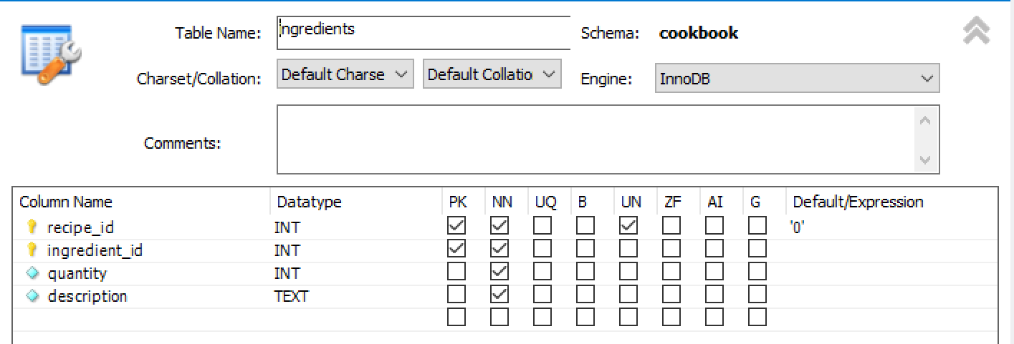

● Table “instructions” includes columns “recipe_id”, “instruction_id”, and “description”.

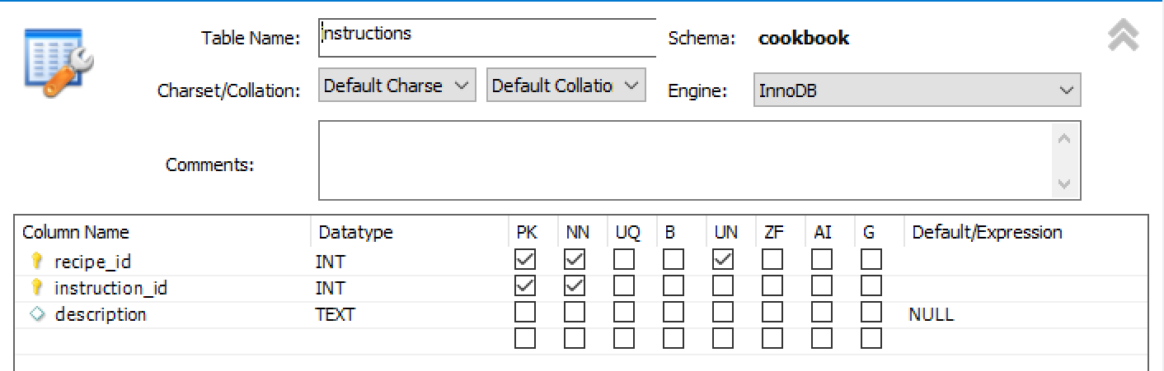

● Table “recipes” includes columns “recipe_id”, “recName”, recRegion”, “imageURL”, “prepTime”, “cookTime” and “serve”.

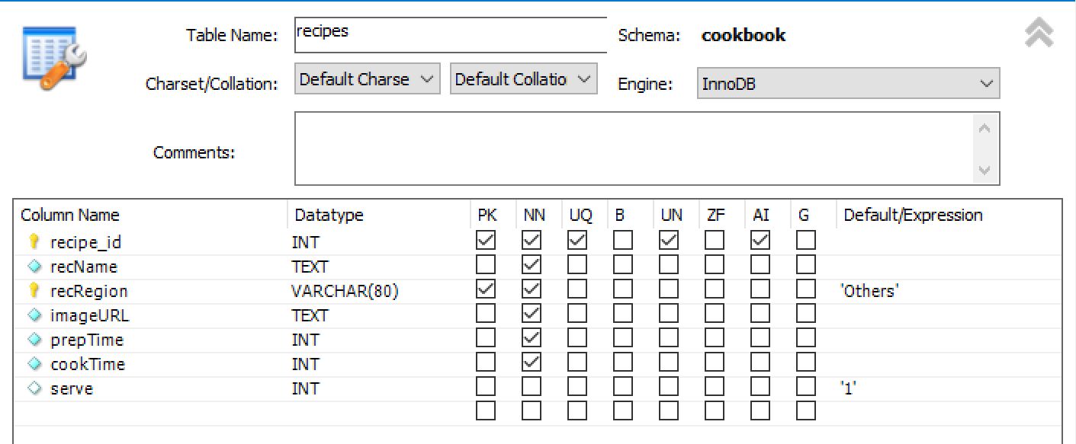

In the provided database, there are 6 default recipe data stored in the database, each region for 1 reference recipe data.

* Region: LA 🡪 Recipe Name: *Coconut & squash dhansak*
* Region: SA 🡪 Recipe Name: *Simple Deviled Eggs*
* Region: SEA 🡪 Recipe Name: *Easy Korean Ground Beef Bowl*
* Region: Others🡪 Recipe Name: *Lemon Pea Salad*
* Region: EU 🡪 Recipe Name: *Lemony prawn & courgette tagliatelle*
* Region: A 🡪 Recipe Name: *Jerk chicken burger*

# **Functional requirements**

1. Store recipes in specific;

According to the existing example recipes, additional recipes can be further added. Besides that, each recipe that has been added to the digital cookbook will have picture content to demonstrate the expected outcome of the dishes.

1. Create, read, update and delete recipes;

Users of the digital cookbook can further modify the all-existing parts of a recipe, meaning that all the content of a recipe can be changed based on the users’ favours. Creating a new recipe, reading the recorded recipe, and updating and deleting the whole parts of a recipe are all possible operations that are available to the users.

1. Search for a recipe by name;

A basic search function is also provided in the digital cookbook, the user can locate and find the desired recipe by typing the valid name of it and the resulting recipe will pop up.

1. Calculate the serving amount

If the user wants to have some precise and accurate amount of all the ingredients inside a recipe, it is possible that he or she can input the precise serve number for this dish, then this cookbook will automatically calculate and return feedback on the specific amount of the ingredients based on different input numbers.

1. Search for recipes in 6 provided regions

Another functional requirement of this digital cookbook is that users should be able to search for recipes by 6 provided regions, including one region name called “others”. By clicking the region selection drop-down box, users are able to see the recipes from one designated region.

# **Non-functional requirements**

1) App should run without bugs or crashes;

2) Good usability;

3) No redundant function

4) Fully ‘documented’ source code

5) This cookbook should display the matched recipes within 5 seconds after a user fill in the recipe name or select a country.

6) Any user who knows how to use the simple application and read and write in English should use the Digital Cookbook without the manual.

# **Architecture**

# **Use case diagrams**

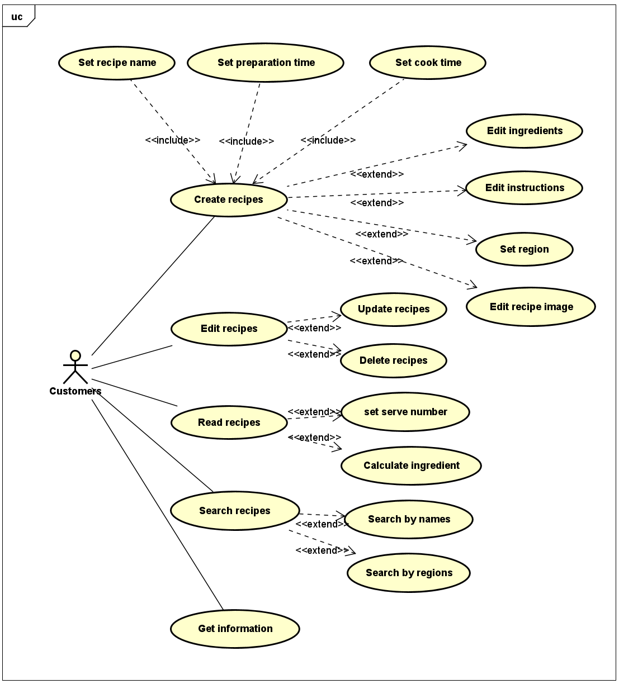

Our use case diagrams have shown as shown above.

At the beginning of the Use Case Diagrams, we need to decide the actor and the use cases. For the functions of the project, we have only one actor, that is the Customers. And the Customers have the operations as follows:

* + **Create a new recipe**. The User needs to create their own recipe, So the function is set to a use case. In the initial windows, the user can choose the button to create a new recipe directly, then the created window will display and the user can modify every parameter about the new recipe, after saving the data will be transported to the database. After clicking the “save” button, the database will add a new recipe and we can find the new recipe in the search window. Thus, we set the function to a use case.
  + **Edit recipe**. To make it more useful, we have the function of modifying the present recipe. For the recipes in the database, we can update them in the detail window: we can change the amount of the kind of the ingredients, the quantity, and the others. After clicking on the “save” button, the new data will be sent to the database and then the database will update. For the function, we set it to the use case.
  + **View the recipe**. Customers can view the detail of the recipe if they want to. The serve number can be altered according to the customer’s situation, therefore the corresponding number of each amount of the ingredients will be calculated to fit the new serve numbers.
  + **Search for recipes by name or by region**. In the initial windows, the user can type the recipe’s name and then click the search button, then the window will switch to the result windows. We set the functions to a Use Case and connected with the User directly. If the user wants to search by region. In our additional task, we need to enable the project to search the recipes by region. So, we need to put it into the initial interface and then set this function to a Use Case which is connecting with the User directly.
  + Last but not least, an **information display** function is also provided, customers can get information and hints on the home page, there will be detailed instructions and guide on how to use our digital cookbook.

# **Structure/MVC**

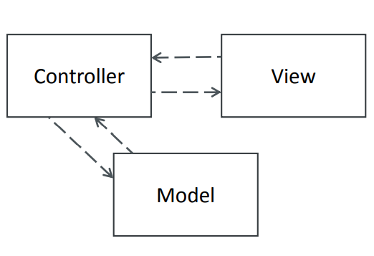

Our code is written in the structure of the MVC framework, meaning that the codes are basically separated into 4 packages, model, controller, view, and main package. Named as meinRecipe_Controller, meinRecipe_Model, meinRecipe_View, and meinRecipe_Main. Also, a package about the connection and the operational functions of the operations in the database is put into another package named meinRecipe_DB, named correspondingly as DBConnector and DBOperator.

This version of the MVC pattern is often used for web applications. We choose the MVC pattern because we used SceneBuilder to design each window in the View part of the application as an FXML file. And we connect each window with an individual controller.

Model part:

1. For a model part, three classes are included:

* Ingredient
* Instruction
* Recipe

1. Controller part:

* DisplayPageController 🡪 DisplayPage.fxml
* EditPageController 🡪 EditPage.fxml
* HomePageController 🡪 HomePage.fxml
* SearchPageController 🡪 SearchPage.fxml
* InfoPageController 🡪 InfoPage.fxml

1. View part:

* DisplayPage.fxml 🡪 DisplayPageController
* EditPage.fxml 🡪 EditPageController
* HomePage.fxml 🡪 HomePageController
* InfoPage.fxml 🡪 InfoPageController
* SearchPage.fxml 🡪 SearchPageController

1. Main class

* Main

1. Database class

* DBConnector
* DBOperator

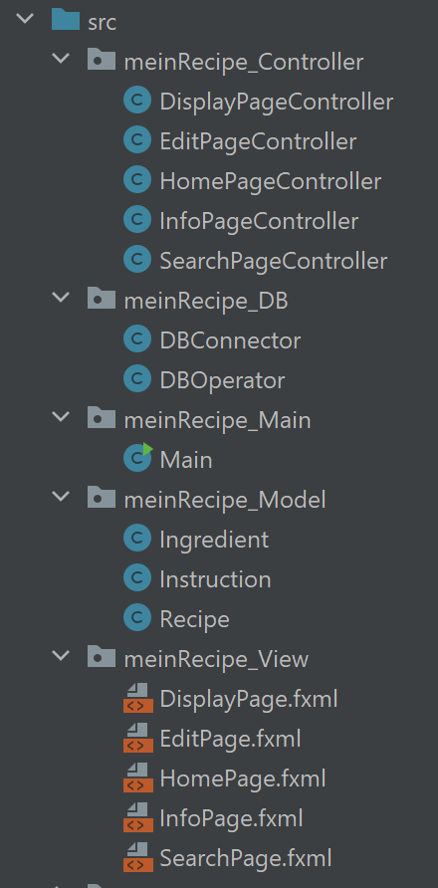

Since we utilize Scene Builder in JavaFX to make our user interface pages, therefore our view pages are separated into 5 pages, including a display page, edit page, home page, information page, and search page. Accordingly, our controller also includes the corresponding controller class to monitor those 5 pages.

# **Class diagrams**

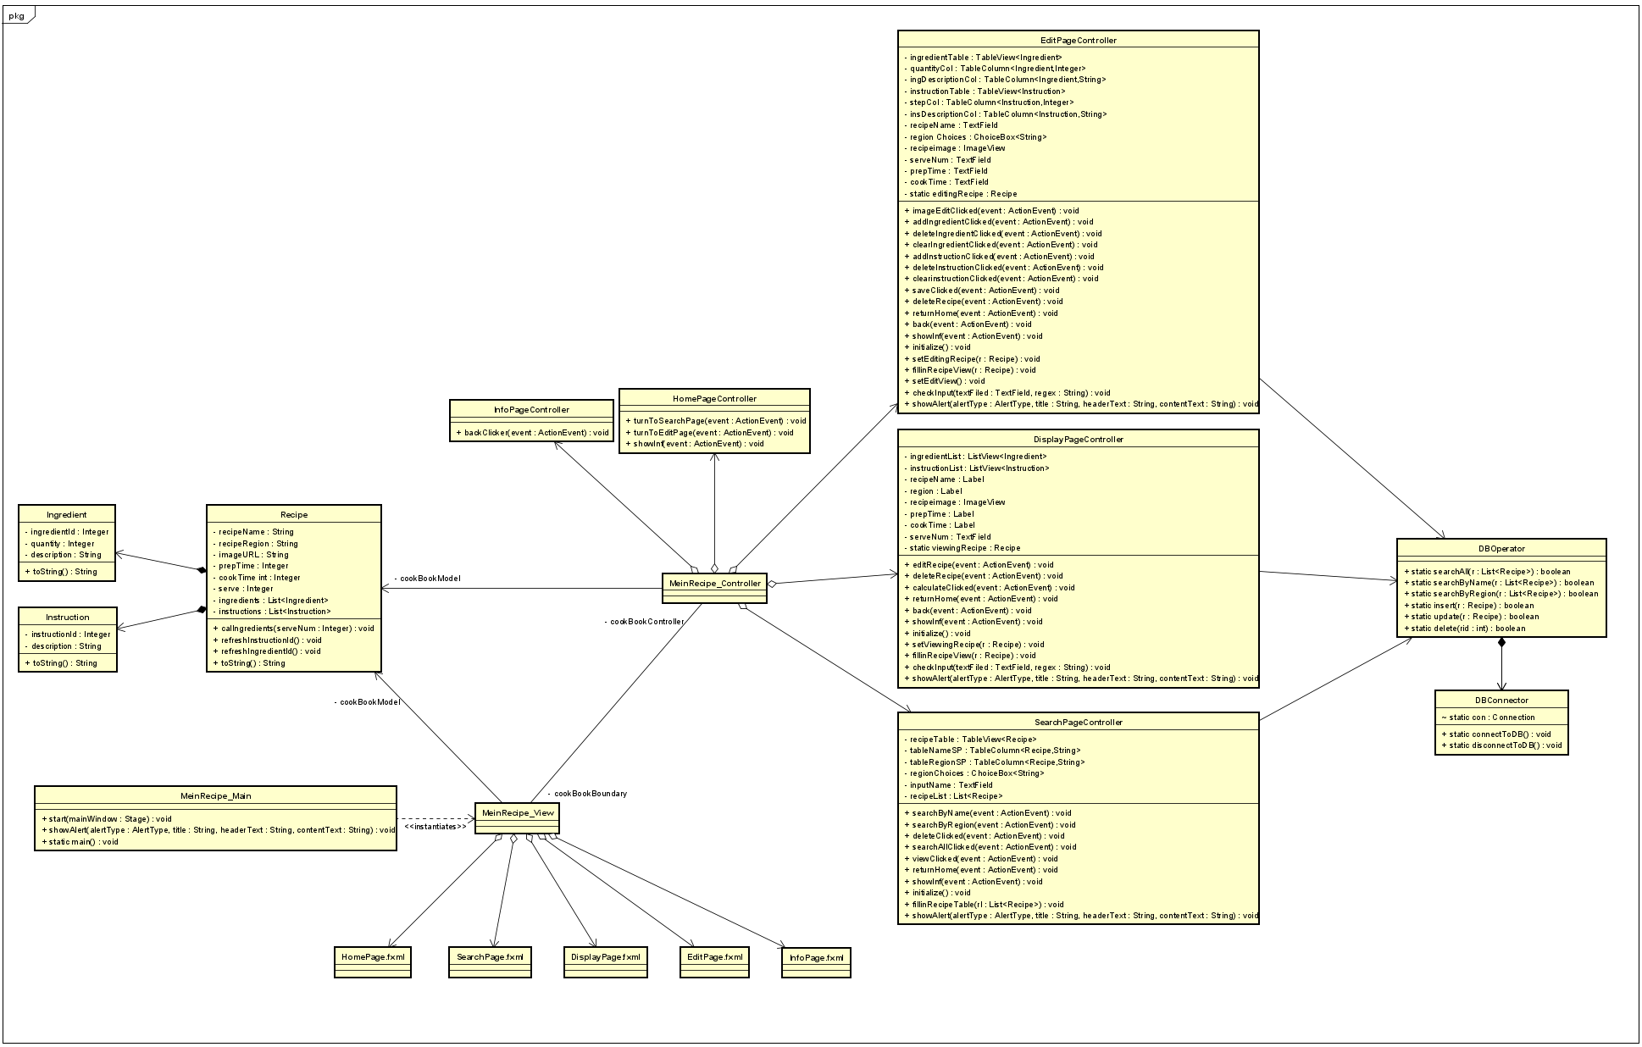

According to the MVC framework, and also including the connection to the database, the overall view of our class diagram is drawn as above. The logic structure of our code is also shown according to the class diagram. All the variables inside each class are set into private, and the functions inside the classes are set into public.

Our class diagram can be interpreted into four big parts.

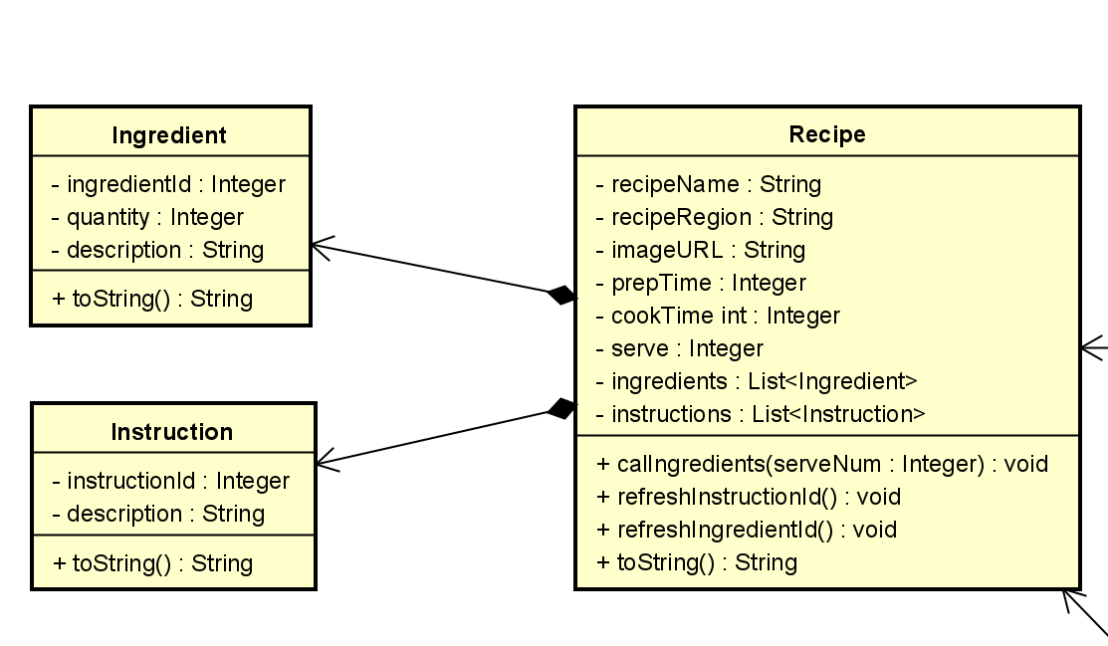

* To be specific, in the first part, there include three classes, Recipe, Ingredient, and Instruction. And the classes of Ingredient and Instruction will be called by the class Recipe.

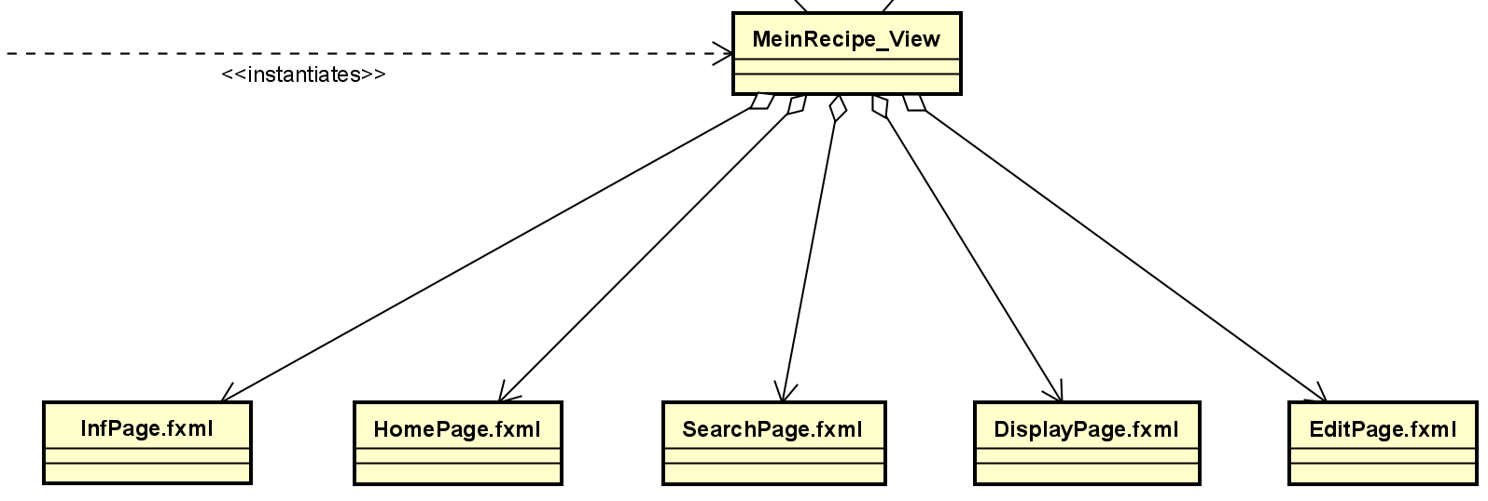

* In the package of MeinRecipe_View. Five .fxml pages are included. And the main view class will be firstly called by package. MeinRecipe_Main

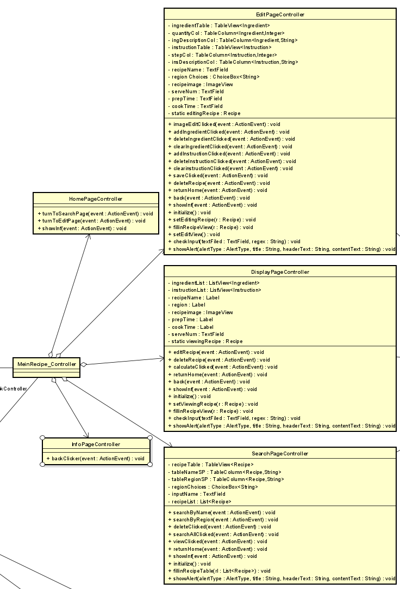

* Since as introduced before, we use scene builder to create five pages, therefore, in the controller, there will be inconsequently five corresponding controllers in the package of MeinRecipe_Controller.

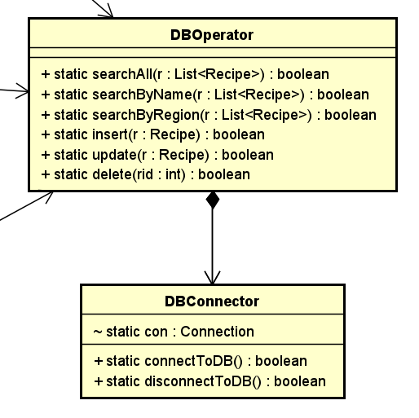

* Another part of our class diagram is the connection and operation of the database. And the class of DBOperator is connected to the three of the controllers’ classes as mentioned before.

# **GUI Design**

# **Structure/wireframes**

Before we use the Scene Builder to construct those different pages of our recipes, at first, a series of simple wireframes as basic structures of our final scene pages have been drawn.

There are all in all 5 pages that we will implement. The first page, of course, is the home page, where the initial page will first pop up once the customer turns on our digital cookbook.

* Wireframes of Homepage.

There exists merely a few necessary buttons and controls on this page. But the logo of our digital cookbook will be shown here.

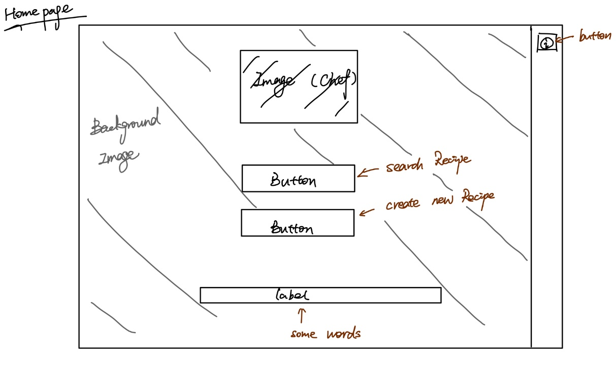

* Wireframes of the Search page.

The following will be the search page, where recipes can be located and found. Users can also have a choice to select their favourite searching methods, either searching by name or searching by region.

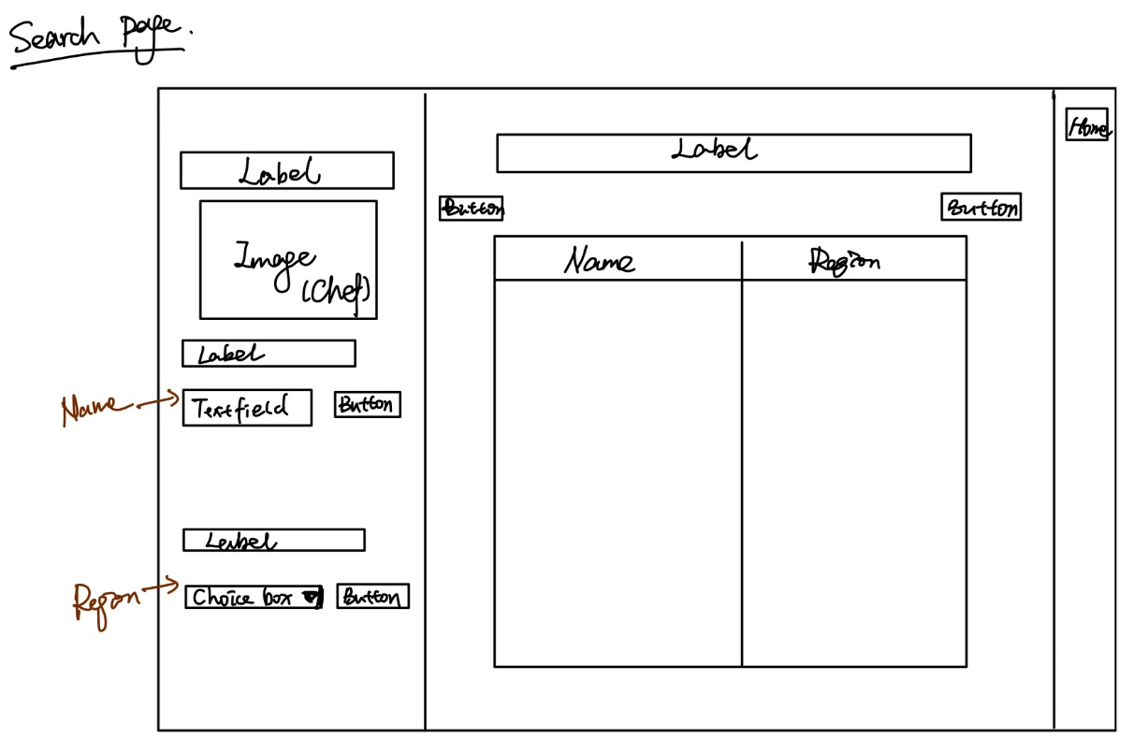

* Wireframes of the Display page.

A display page, where details of one specific recipe will be shown.

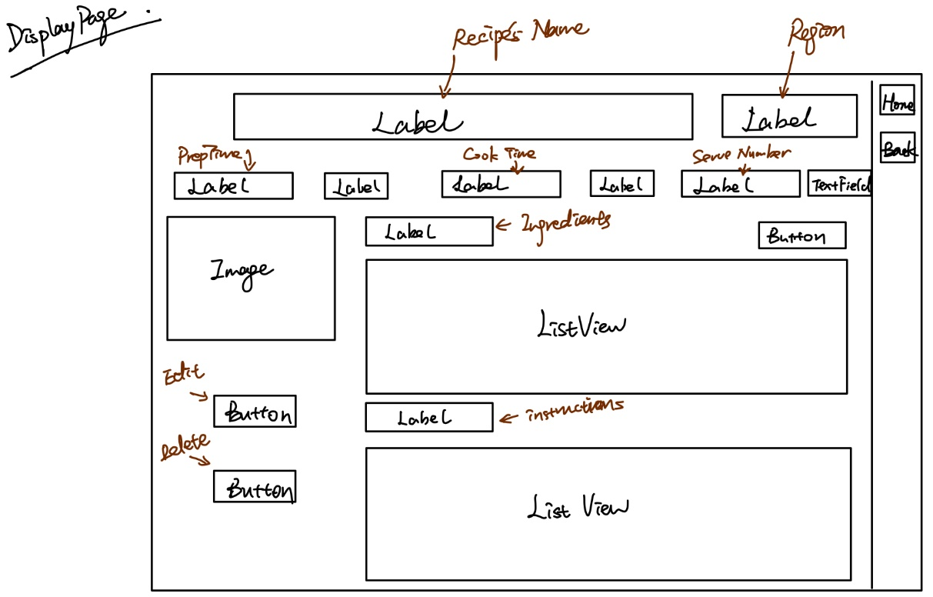

* Wireframes of Edit page.

Next is the edit page, where all parts of the information about this recipe can be alerted here.

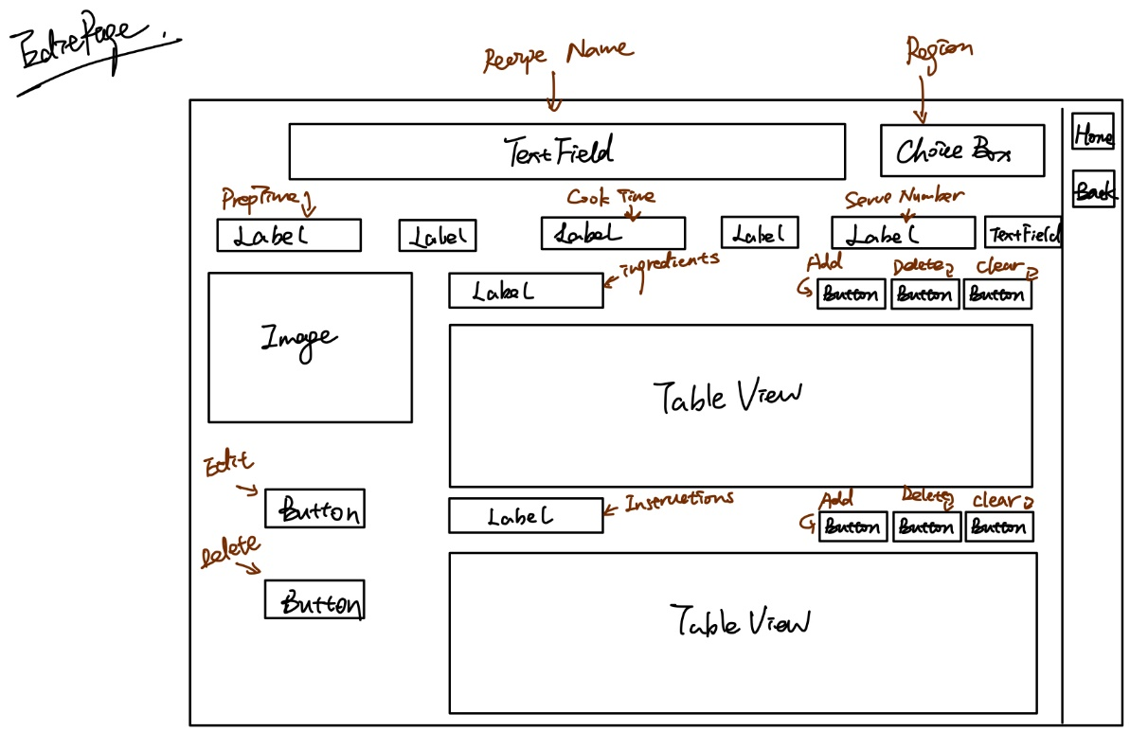

* Wireframes of Information page.

When pressing the information button on the home page, the information page will be shown here.

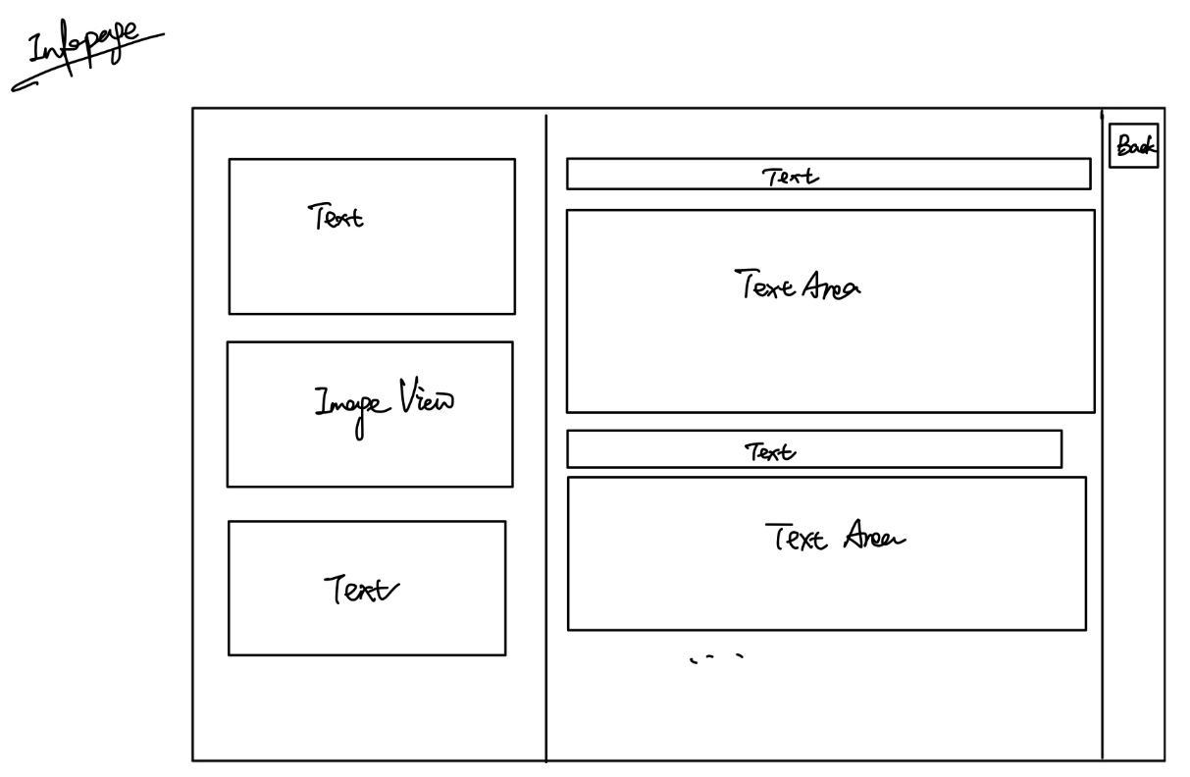

# **Application of usability heuristics with screenshots**

Here are the actual demonstrations of our 5 GUI interface pages, which are accordingly, named as Home Page, Search Page, Display Page, Edit Page, and Info Page.

Besides those five main pages, there are also a host of different kinds of warning windows, error windows, and some hints that will pop up as a reminder to the users when necessary.

* Home Page

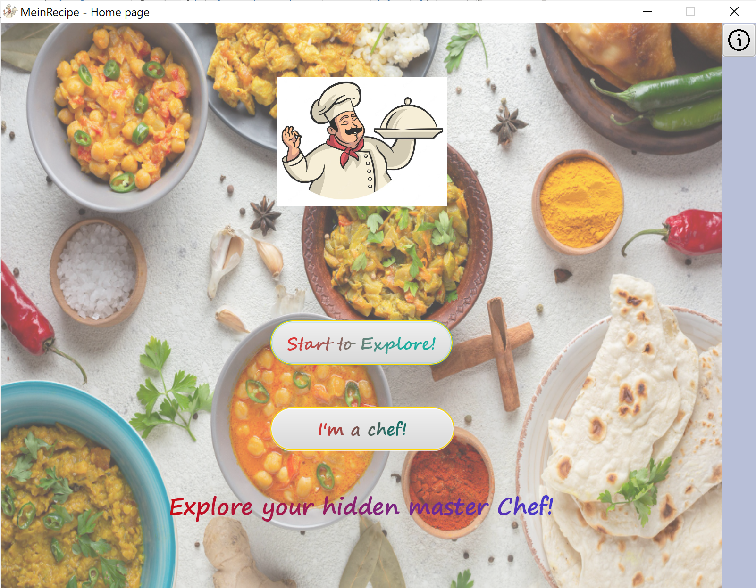

On the initial page of our digital cookbook, the home page will show as above. There exist two buttons, the “Start to Explore” button and the “I’m a chef!” button, which will navigate to the other two pages that is corresponding to a “Search for recipe” page and “Create recipes” page.

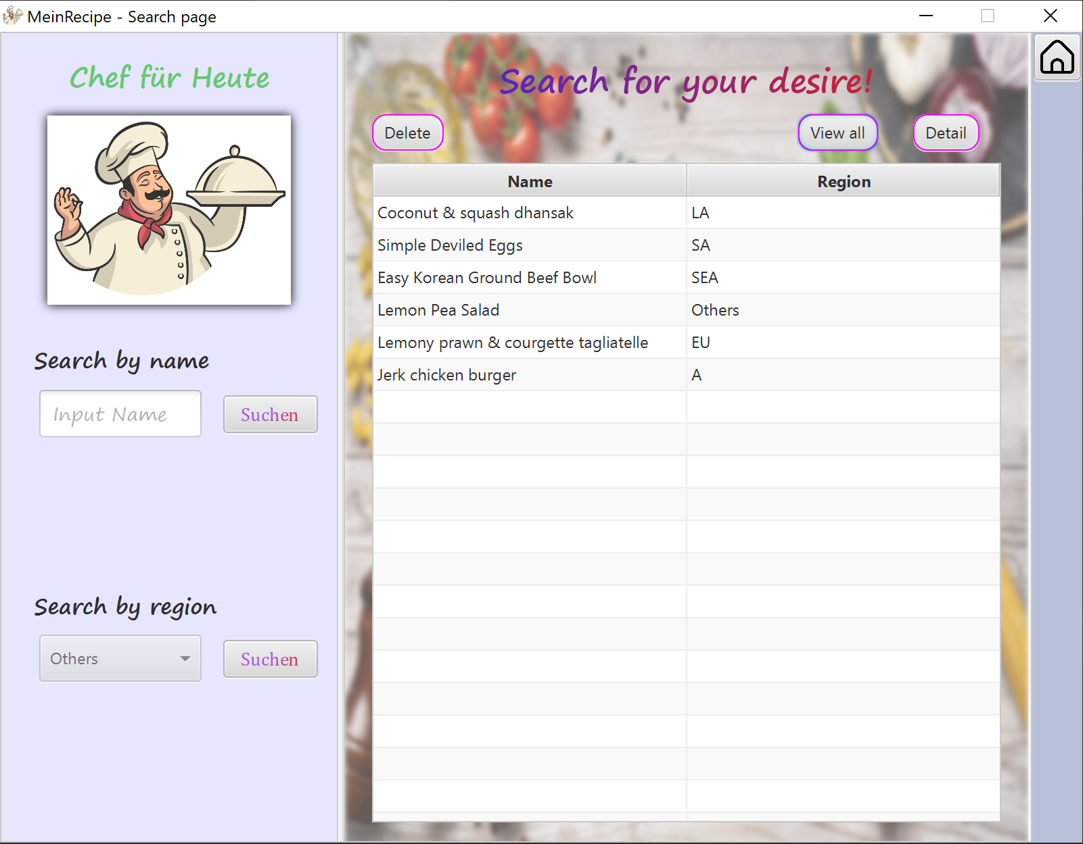

After clicking the “Start to Explore!” button, the following search page will show as above. Users can type their desired recipe’s name into the button below “Search by name” words. Besides that, users can search the recipes by region, as shown down below. Then, the relative recipes will show inside the table column.

By clicking the “Delete” button on the right, after selecting one specific recipe, the recipe will be deleted from the database. By clicking the “View all” button, all recipes contained in the DB will be listed inside the table. By clicking the “Detail” button, the page will be switched to another page, the “Display page”.

Besides this main view.

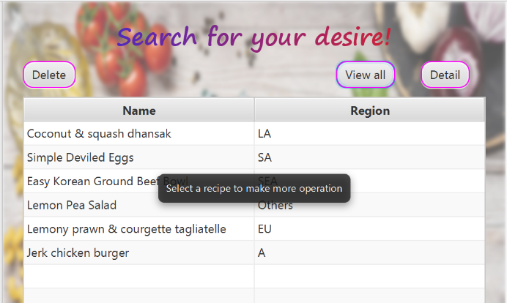If you pause your mouse on the column list for a few seconds, there will be a hint suggesting you to select one recipe for more information.

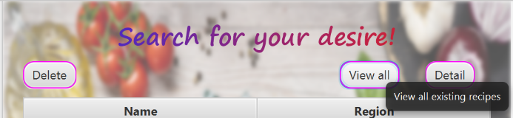There are also texts, give some further information about the functions of those buttons for the benefit of users.

Besides that, there are also some pop-up windows in this page for better usability.

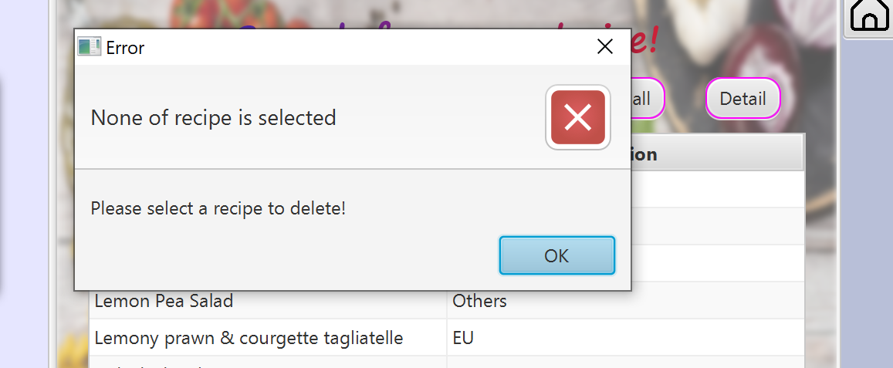For example, if user simply click the “Delete” button without selecting any recipe in the display column, then an Error window will pop up remining user for his invalid operation.

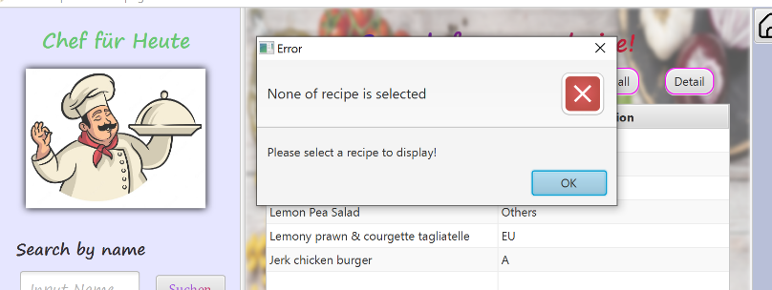The identical Error window will pop up as for invalid operation of “Detail”.

* Display page

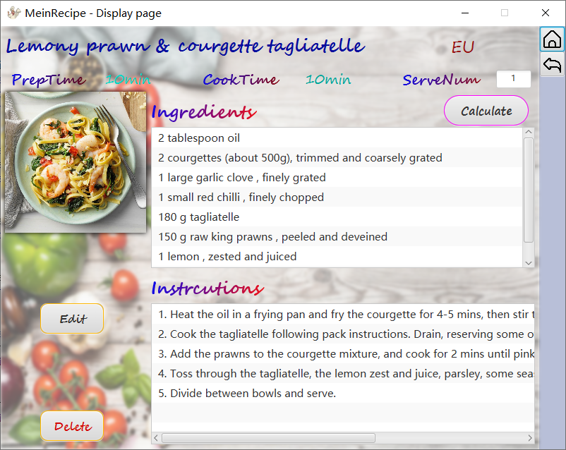

There are all in all three operations that one can make inside this page, by inputting the serve number and then clicking the “calculate” button, the number of ingredients will be changed according to the serve number.

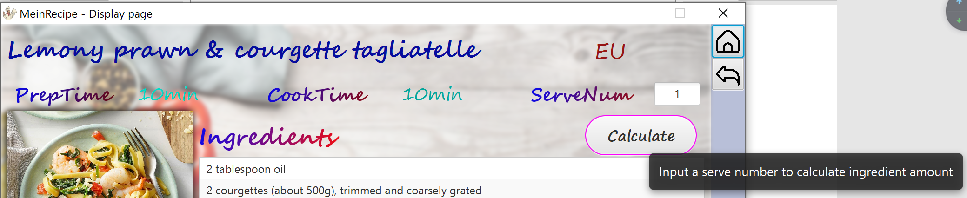

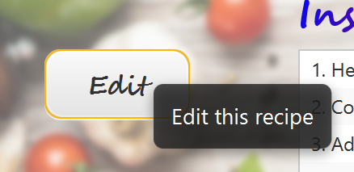Another operation is by clicking the “Edit” button, then, the page will switch to the “Edit Recipe” page, and all the page information on this page will be transported directly into the edit page.

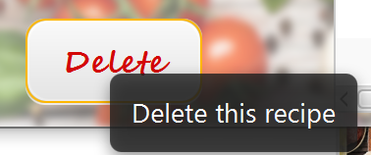The last button “Delete”, as we all know, delete button will complete a delete operation, and the selected contents from the responding recipe in the database will be erased.

* Edit page

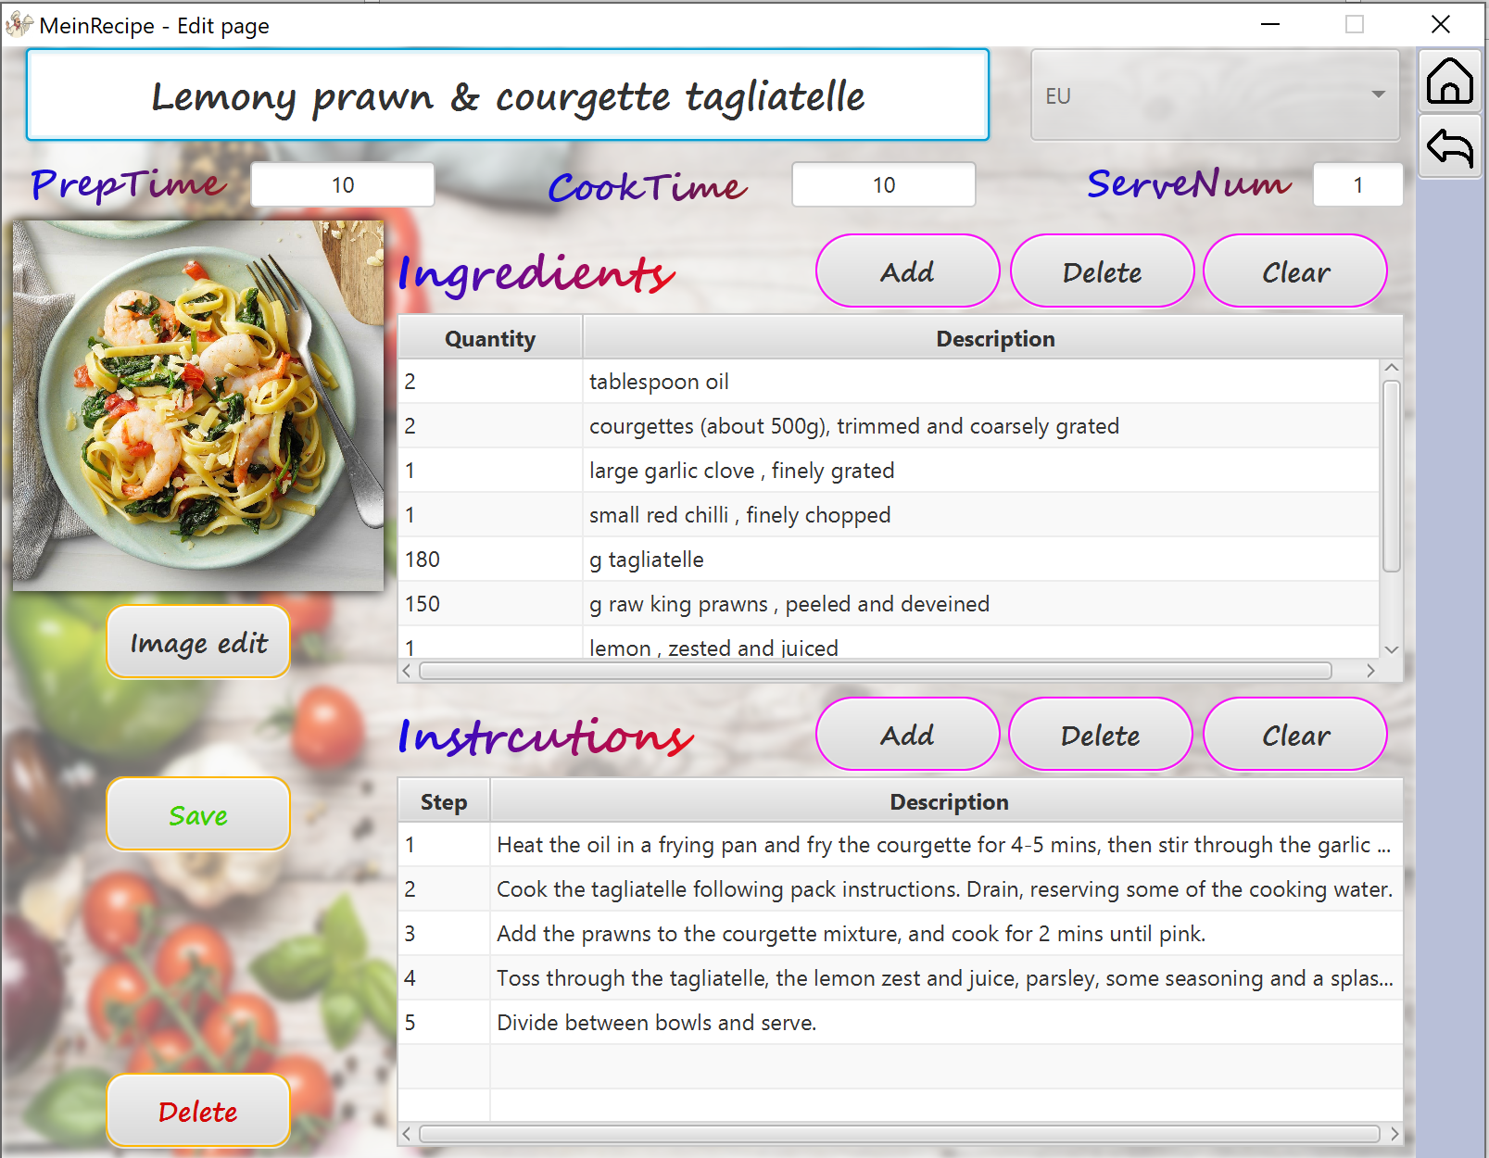

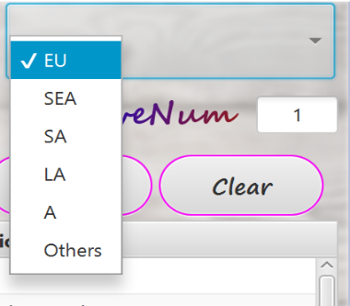Inside the “Edit page”, all part of the information inside the recipe can be alerted. Importantly, users have to click the “Save” button to total complete the operation toward the alerting of the recipe.

To be specific, users can edit the region of the recipes from the provided 5 regions, they may also select others if the desired region is not listed in our data list.

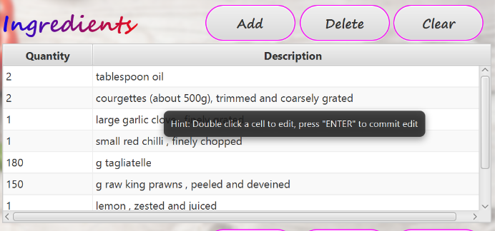In the column of “Ingredients” and “Instructions” there also some hints provided for better useability.

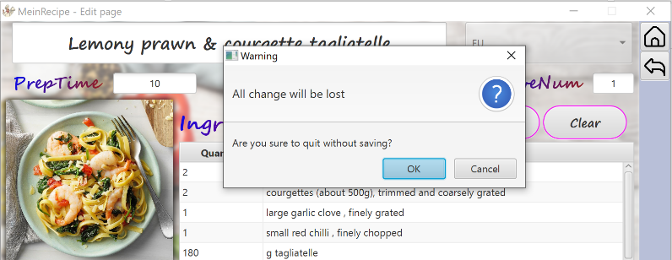 if customers try to leave this page without clicking save button at the button, a warning window will pop up as a reminder.

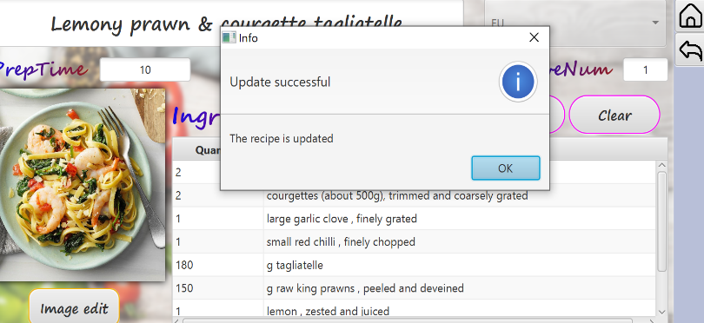Or if customer click the save with no any invalid input, then an Info window will pop up showing successfully updated.

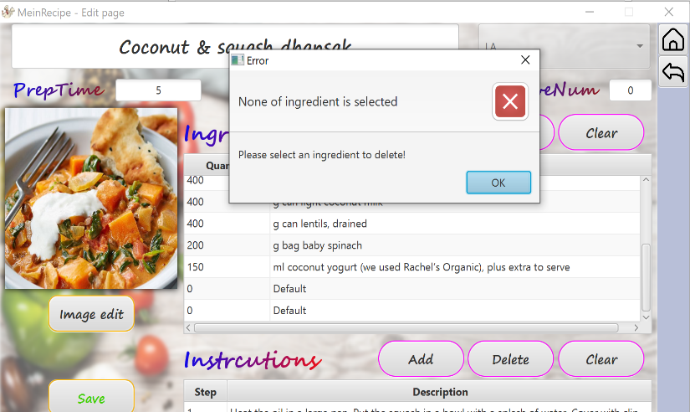The same error window will show for the remining function.

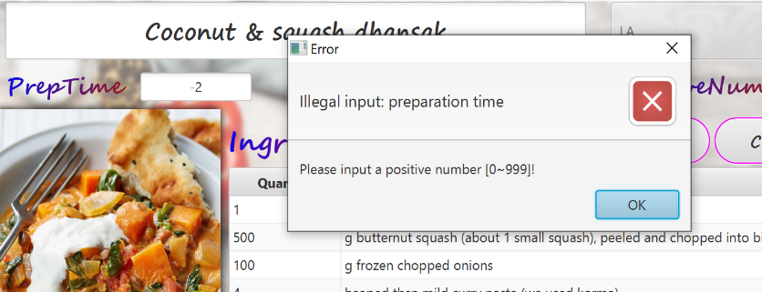Furthermore, if an invalid input number is given by the user, for example, the value of the preparation time is not valid, out of the boundary of [1, 999], then an Error window will show for illegal input of preparation time.

* Info page

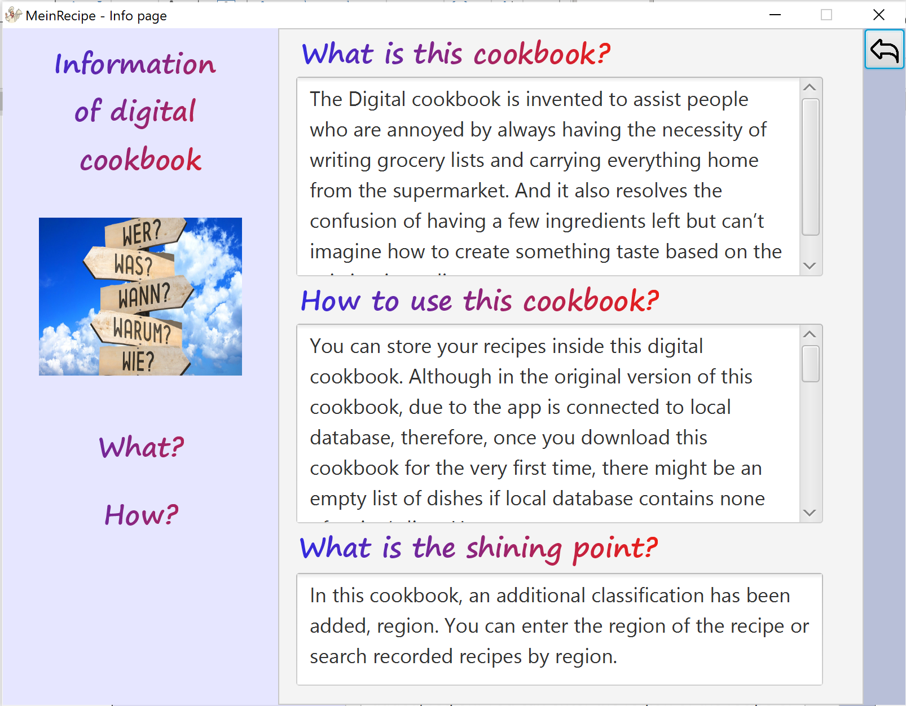

The last page will be “the Info page”, users can activate this page by clicking the information icon on the initial page of digital-book, there exist a host of instructions for this cookbook, and also its functions and synopsis.

* Besides, all these main windows, there also includes some the alert windows that will pop up to inform users of some notifications, and warnings. Including warning about illegal input, null input, selecting one specific recipe before showing the details, and so on.

# **Test**

# **EC/BVA**

# **Description**

According to the input principle and also according to the basic logical rule towards the number of the service people, that is, at minimum, there should b

e at least one person to be served thus the initial serve number should be more or equal to 1. The boundary of the serve number is below 99, or otherwise, if the serve number is largely over 99, it is not practical and logical to prepare for such that large number of people.

Likewise, for the cooking time and the preparation, the initial time should be more than 1 min, or it is not logical for a people to get one dish prepared and done in less than 1 min. The upper boundaries for those time are both defined as 999.

The quantity of the ingredients is expended to a wider range, from 0 to 9999.

Here below are the Equivalence classes.

1. Equivalence classes
2. Serve number in the edit page and also in the display page should be positive integer number within [1, 99]

Input: Range of value

Valid EC V1 = {value |1 <= value <= 99}

Invalid EC V2 = {value | value < 1}

V3= {value |value > 99}

1. Cook time and the preparation time should be positive integer number in [1, 999]

Input: Range of value

Valid EC V4 = {value |1 <= value <= 999}

Invalid EC V5 = {value | value < 1}

V6= {value |value > 999}

1. The input of quantity should also be positive integer number in [0, 9999]

Input: Range of value

Valid EC V7 = {value |0 <= value <= 9999}

Invalid EC V8 = {value | value < 0}

V9 = {value |value > 9999}

# **Results**

In this short chapter, the results of the EC and BVA test will be demonstrated and introduced here. To be specific, the test for EC, boundary variable analysis and test for BVA.

1. Test for EC

|  |  |  |  |
| --- | --- | --- | --- |
| **Inputs/Test No.** | **1** | **2** | **3** |
| **Serve Number** | 0 | 101 | 6 |
| **Cook Time** | 77 | 45 | -2 |
| **Quantity** | 5 | 52 | 12 |
| **Covered EC** | V2, V4, V7 | V3, V4, V7 | V1, V5, V7 |

|  |  |  |  |
| --- | --- | --- | --- |
| **Inputs/Test No.** | **4** | **5** | **6** |
| **Serve Number** | **78** | **12** | **6** |
| **Cook Time** | **1004** | **6** | **36** |
| **Quantity** | **3** | **-3** | **100453** |
| **Covered EC** | **V1, V6, V7** | **V1, V4, V8** | **V1, V4, V9** |

1. Boundary value analysis for suited values
2. Boundary value for ***serve number***

**EC:**

G1 = {value | value < 1}

G5 = {value | value > 999}

**Boundaries**

|  |  |  |
| --- | --- | --- |
| **0** | **1 99** | **100** |
| **invalid** | **valid** | **Invalid** |

1. Boundary value for ***cook time and preparation time***

**EC:**

G1 = {value | value < 1}

G5 = {value | value > 99}

**Boundaries**

|  |  |  |
| --- | --- | --- |
| **0** | **1 999** | **1000 99999** |
| **invalid** | **valid** | **Invalid** |

1. Boundary value for ***quality***

**EC:**

G1 = {value | value < 1}

G5 = {value | value > 99}

**Boundaries**

|  |  |  |
| --- | --- | --- |
| **-1** | **0 9999** | **10000 999999** |
| **invalid** | **valid** | **Invalid** |

1. Tests from BVA

**Boundaries:**

|  |  |  |
| --- | --- | --- |
| **0** | **1 999** | **1000 99999** |
| **invalid** | **valid** | **Invalid** |

**Tests vases for:**

0, 1, 30, 999, 1000, 9999(🡪Borders)

**Boundaries:**

|  |  |  |
| --- | --- | --- |
| **0** | **1 999** | **1000 99999** |
| **invalid** | **valid** | **Invalid** |

**Tests vases for:**

0, 1, 60, 999, 1000, 9999(🡪Borders)

**Boundaries:**

|  |  |  |
| --- | --- | --- |
| **-1** | **0 9999** | **10000 999999** |
| **Invalid** | **valid** | **Invalid** |

**Tests vases for:**

-1, 0, 60, 9999, 10000, 999999(🡪Borders)

# **Usability test**

# **Description**

In the field of usability test, we are intended to find and collect some usability data which carried out by letting some of our testers, who have no background knowledge of our digital cookbook, and also without prior experience of using our cookbook.

Before they have the experience of using this system, we don’t, at the beginning, give extra assistances and helps besides that information provided in our cookbook and those instructions

such as README.md from the GitLab of our cookbook.



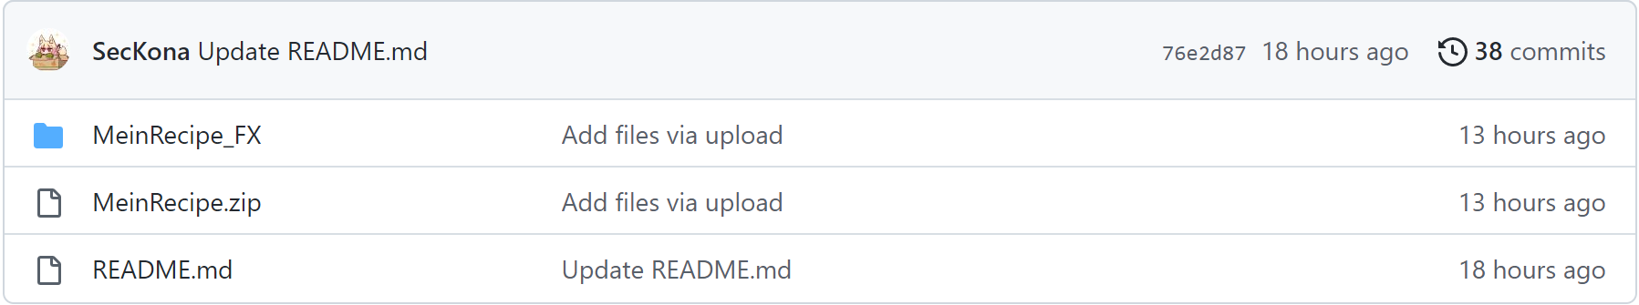

For the testers, we have given over 5 people aging from 18 to 57 to guarantee that our test data will be as complete as possible and include a wide range of different groups of people, from who might be quite familiar and skilled to the use of computer and the internet to who might slightly not get use to using the version of digital cookbook.

After all the testers have done the experiments, their experience and feeling are collected and recorded and we also carried out a series of questions to further ask what is in their mind regarding to some specific field.

For example, in the creating recipes page, is those data that need to be inputted, adequate enough for them to input all the necessary information needed to cook the dish?

Also, especially, are the hints, guides and all the information that provided in our digital cookbook adequate and clear enough for them, that they can accurately and correctly operate and use our digital cookbook.

# **Evaluation/results**

1. **Scenario 1**

Our first tester. Age 21.

Julia is a college student who is quite familiar and skilled with the computer. However, she is not an expert in cooking but she is always willing to search on the Internet to follow the guide to cook.

After she has used this digital cookbook, the most impressive feeling and experience she said is that there should be more of the operation prompts. e. g. When user hover their cursor on a control like buttons/choice boxes, there should be an operation prompt to give some hints about how to use these controls.

**Solution:**

For improvement, we add the hints to all the buttons, therefore, if one has any confuse about some specific buttons or the functions of the choice boxes, there will be possible to provide more of the extra information to the customers.

1. **Scenario 2**

User II. Age 22. (Student in IT)

Alex is a student, who is always like to search for something new and interesting. The most critical part for him is the searching part. Therefore, when he tries to search for some recipe names, he accidentally typed in a symbol “ ‘ ” into the searching box. Then he finds out that there is something wrong with the database. He figured out that our basic operation classes have some defects: When user type in character like ‘ in textField for Search-by-name function, database will occur some fault which led to failed search.

**Solution:**

Aiming to deal with this kind of problem, we changed our code from Statement class to PreparedStatement class. The fault above was then fixed.

1. **Scenario 3**

User III. Age 51. (A mother)

Alice is quite good at cooking, and she used to write a lot of her creative recipes by herself. We invite her to test our program and test for her personal experience of using this cookbook.

She is more interested in typing in her own invented recipes into the database, but when she tried to into some steps information from the interface into the database, add much more information into the row of the tableView, then slider on right side of tableView cannot be dragged. Therefore, some of the data of the inputted information is covered.

**Solution:**

This fault was fixed by change setEditView() method in EditPageController class. (Jierui Li)“I searched some ways to resolve conflicts of Table-like-edit-model and illegal drag of columns in table view.” In details, by using lambda expressions, our program`s edit page enable user to edit ingredients and instructions table conveniently. User could double click a table cell to edit, then press "ENTER" on keyboard to commit edit. (Although this operational logic is a little counterintuitive, I failed to find a better way for edition. I`ve tried to use customized class to realize automatic edit commit by rewriting setOnEdit…() methods, so that table cell will automatically commit edition when focus lost. But there are some type mismatches leading to unusable customize class. Thus, I added some operation prompts in these controls)

# **Evaluation**

# **Group work**

In our group, there are merely two students, therefore, our responsibilities are distributed more clearly. Also, due to the small scale of our group, we have a quite instant, frequent and responding communication throughout the entire construction of our digital cookbook. I personally perceive that; our group can complete our tasks in a much more efficient and convenient way than other groups which consist of 3 students.

* Leader: Hengyu Wang

I'm honourable to be selected as the team leader to complete this project. Organizing and completing the tasks of assigning jobs, coordination and cooperation. As a team leader, I need to be familiar with the project so that I can be more capable of assigning and monitor the process of our project.

In this project, I'm in charge of all the GUI, word file and code testing parts. It costs me a few days to totally acquire of the use of Scene Builder. To connect to the database, we learn and use the MYSQL to complete this task.

After this group project, I realized that I need to be familiar with all parts of the project, so that I can solve most of the problems and bugs. Also, I need to regularly get a connection with the process of my group member so that we can get in touch with each other and share some puzzles and questions in time, therefore, the procedure of the project would not be delayed. For both of us, MySQL is a grand new software. At first, we thought it was just some lines of code to connect the database. But then I realize that there exist some of the bugs during the connections of these two parts.

I am very grateful to have this opportunity to learn much not only in coding, but also in group work. This experience will certainly help me a lot in dealing with Java development and teamwork in the future.

* Member: Jierui Li

More than a “coder”: During implementation progress of this project, there is much more difficulties than just writing down some codes. After implementation of the entity class, I realized why we need to override toString() method. What`s more, implement of those controller class requires that we should keep communicating well between front end and back end. There is always some problem and conflicts between function requirement and implementation. Also, we found out that GitHub is such useful for development synchronization in group. Only by learning to use more tools can we make differences as a programmer.

# **Task responsibilities**

Since our group contains merely two students, both of us should be familiar with what each other has done, and also have the basic idea of what our project’s functions and features are. Therefore, if one person has any questions or have any confusions towards one specific task, the other could be able to give out some of the suggestions and ideas to the other.

The following is our detailed task responsibilities.

* Hengyu Wang

1. Supervise the process and procedure of our project.
2. Organize a kick-off meeting with teammate about the task distribution and determine our additional task.
3. Draw the class diagram and use case diagram of our project.
4. Coordinate the time schedule for two of us, and also arrange the weekly discussions times with our student tutor.
5. Learn the knowledge of JavaFX and the instruction of how to use Scene Builder. Sketching and drawing the 5 user interface pages of our project, and named the necessary controls and response functions on the interface pages.
6. Test the running of the codes and find some bugs.
7. Revise and purify the diagrams and word file in the end.
8. Write the whole Word file Project Report, beside the usability test ii.

* Jierui Li

1. Construct basic program frame (MVC, entity class).
2. Construct MySQL database model (Adaptation from given model, add all needed characteristics and constrains).
3. Code about database connection & operation module.
4. Code about controller for GUI*5 and basic function test.
5. Some adaptation of .fxml file to meet function requirement.
6. Write Javadoc for all class.
7. Write “READEME.md” markdown file.
8. Maintain of project file in GitHub for communication in group. ([SecKona/SEII-Project: project files for software engineering II (github.com)](https://github.com/SecKona/SEII-Project))